TSNE Interpretation

1.GAT (Graph Attention Network)
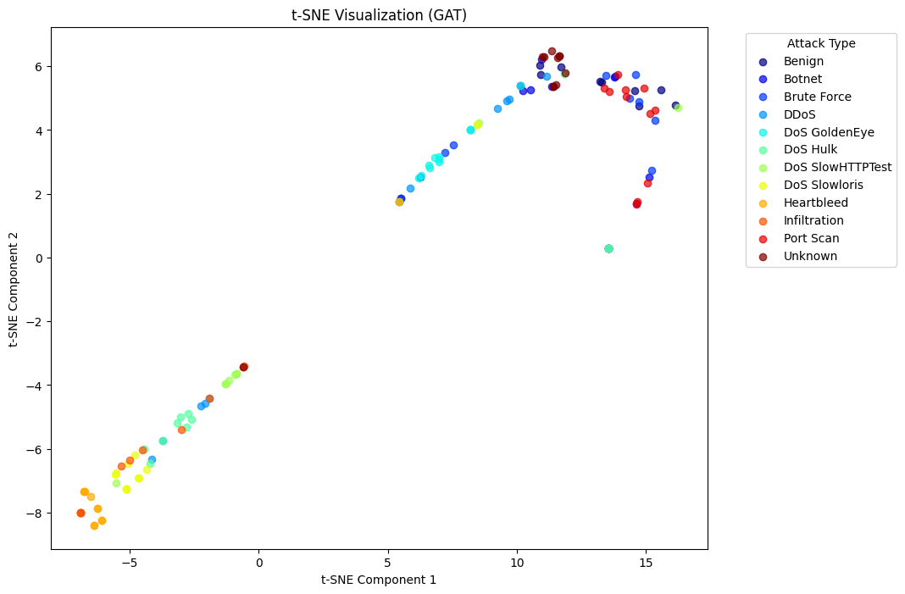
- Observations: The data points appear well-separated, forming distinct clusters.
- Interpretation: GAT effectively differentiates between classes, suggesting strong feature extraction capabilities through attention mechanisms.
- Strength: Captures intricate dependencies between nodes.

2. GCN (Graph Convolutional Network)
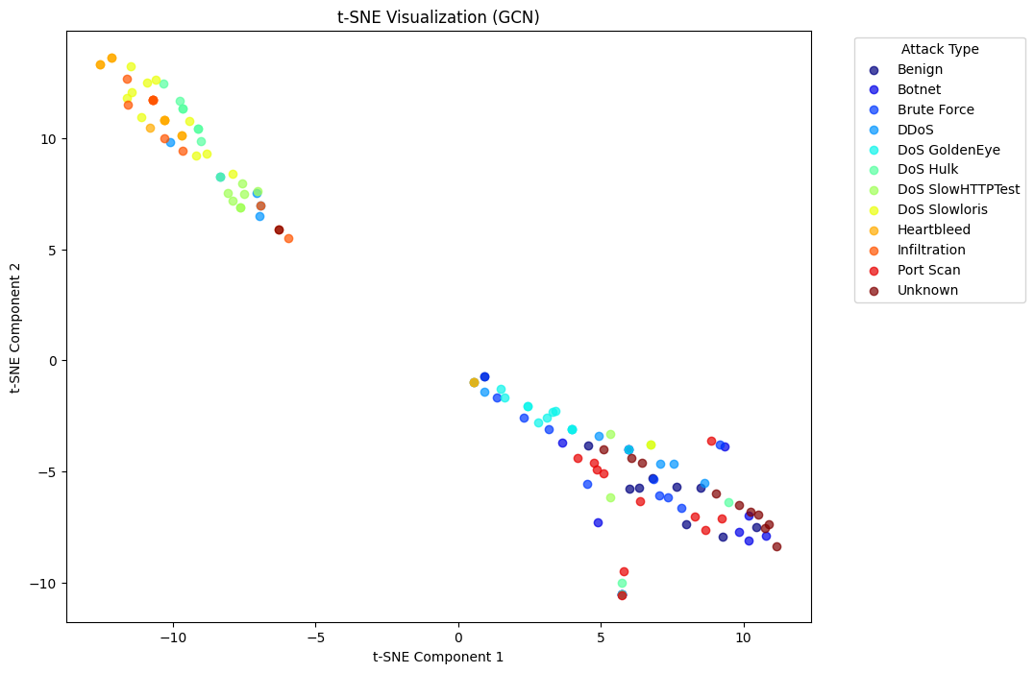
- Observations: There is some clustering, but there is overlap between classes.
- Interpretation: GCN performs reasonably well, but some classes are not as well-separated as in GAT.
- Limitation: May struggle with learning fine-grained class boundaries.

3. GIN (Graph Isomorphism Network)
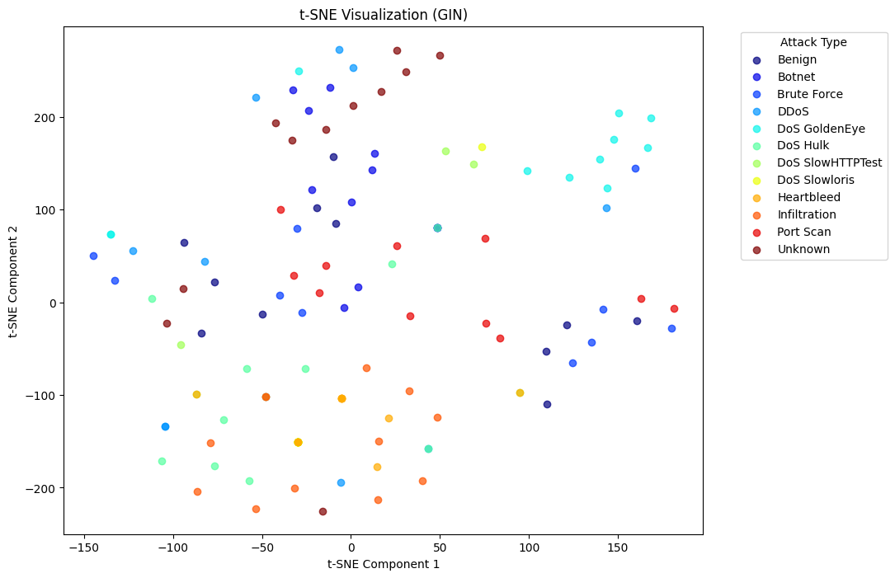
- Observations: The data distribution appears more spread out, with mixed clusters.
- Interpretation: GIN may be learning more general features, but the separability of classes is not as strong.
- Limitation: Less structured clustering might indicate difficulties in capturing distinguishing features.

4. GraphSAGE

- 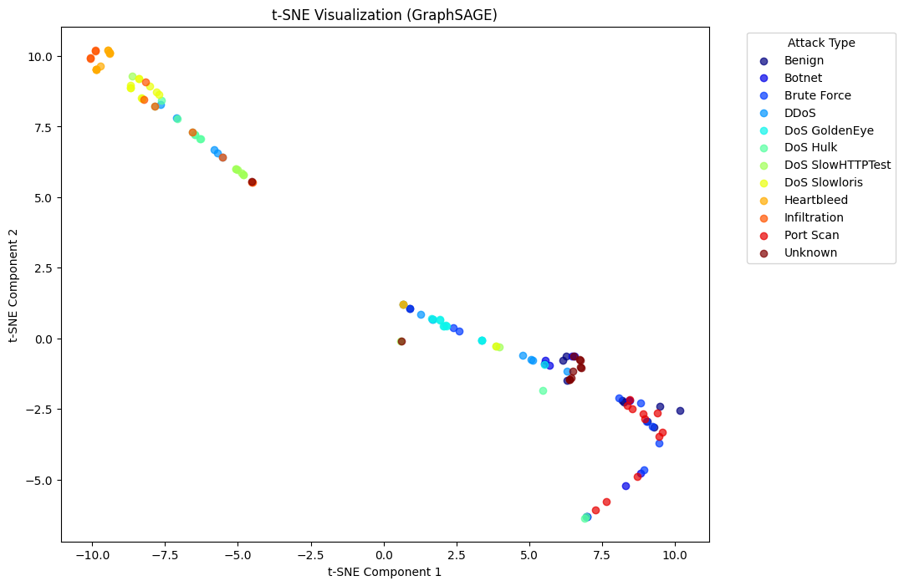
- Observations: Similar to GAT, GraphSAGE forms relatively distinct clusters.
- Interpretation: The model effectively extracts meaningful representations, indicating its strength in inductive learning.
- Strength: Good performance on unseen graph structures.

5. MPNN (Message Passing Neural Network)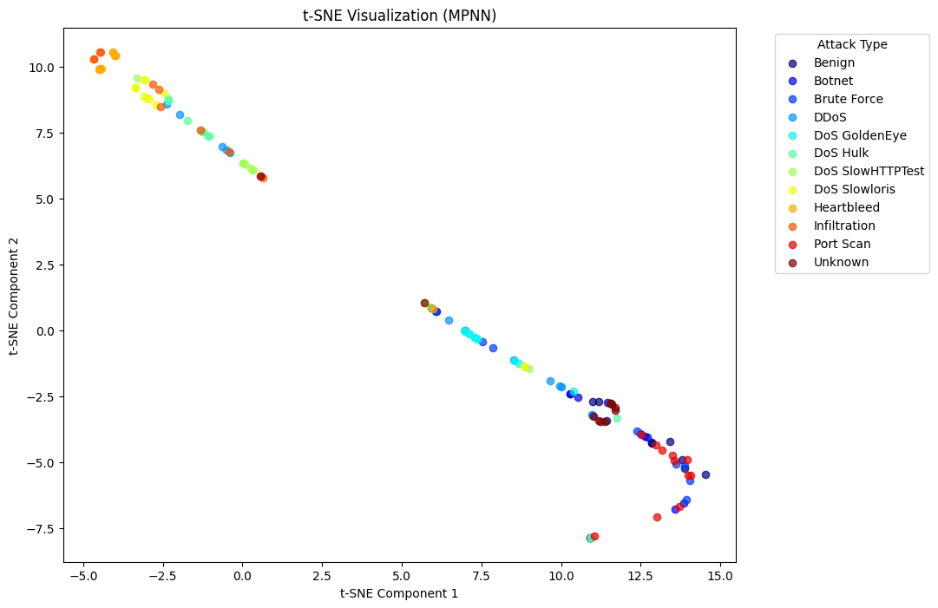
- Observations: The clustering is clear, with some overlap in certain regions.
- Interpretation: MPNN performs well at structuring the latent space, but minor overlap suggests room for improvement.
- Strength: Good feature extraction through message passing.

Conclusion
- Best separability: GAT and GraphSAGE seem to perform the best.
- Moderate performance: MPNN and GCN.
- Least structured clustering: GIN, indicating potential limitations in feature extraction.

